Running Head: USING TECHNOLOGY TO MEET THE STANDARDS

Full Research Report: Using Technology to Meet the Standards

Sally Adams

University of California, San Bernardino

Introduction:
Throughout the traditional classroom setting, the methods for teaching, learning, and assessing are changing. As new technologies are being introduced to help make the classroom a more engaging environment for the digital natives (students), teachers are evolving and themselves learning how to seamlessly incorporate these technologies for both their and the students’ benefit. One of the newest components being introduced in the classroom is a student response system. Teachers are checking for understanding and giving formative and summative assessments via these responders. The hope is that through the use of a student response system, the teachers will be better able to assess, re-teach, and re-assess, resulting in greater comprehension and results from the students.
Research Topic: Using technology tools to increase student achievement on district benchmark exams.
Research Questions:
- How often are the responders used in the classroom?
- What is the student perception of the responder?
- What is the teacher perception of the responder?
- Can the use of a responder (student response system) for formative and summative assessments improve scores?
Hypothesis: The use of a responder for formative and summative assessments will improve scores on district level benchmark exams.
Rationale: The Desert Sands Unified School District (DSUSD) is in the process of implementing an Enhancing Education Through Technology (EETT) grant, where one of the goals is to “improve academic achievement of the state content standards” (California Department of Education, 2009). We are endeavoring to meet this goal by providing our teachers with technology training, teacher-created technology-rich lesson plans, classroom computers, Renaissance© responders, and several types of software. I was interested in conducting my own research on this topic to find out if we truly are succeeding in what we said we would do.
I anticipated students to be more engaged in lessons which are presented with the technology tools available. I also documented the types of lessons used with the technology, and their frequency. Additionally, all grant participants are required to use their responders for the benchmark exams rather than the traditional scantron forms. The combination of these tools showed an improved score on the benchmark exams which took place toward the end of November.
Population Served: The population studied included a sample of 5th grade teachers and students from across DSUSD. There are currently 56 participating teachers out of 73 5th grade teachers district-wide in the EETT grant. The sample teachers included the 6 mentor teachers who were chosen as mentors based on experience and comfort with technology. The remaining sample of 5th grade teachers were chosen randomly from the participant list for a total of 28 sample classrooms with most elementary schools represented. There are not any EETT participating teachers at Ford and Carter elementary schools. The data from the first benchmark exam from the 5th grade teachers last year (08-09) showed that 41% (232/570) of the students scored proficient or advanced. While these are not the current focus group of students’ scores, it is a representation of the focus teachers and how their classrooms performed prior to receiving the new technologies.
There are approximately 766 5th grade students in the 28 sample classrooms. These students represent over 12 ethnicities, multiple languages, and varying social economic statuses. Some of the students also have special education needs. 6% (46/766) of the students took the CMA (California Modified Assessment) last spring instead of the CST (California Standardized Test). Of the 50 students who took the CMA in the spring of 2009, 48% (24/50) scored proficient or advanced. The remainder of the students who took the CST in the spring of 2009, 60% (460/766) scored proficient or advanced. The ultimate goal is to have 100% in this target area.
Literature Review:

- Introduction
In today’s classroom, most teachers are expected to integrate some type of technology into their routines. Selecting the right technology tools and using them effectively can be hindrances for some teachers. However, with support, this seamless integration is resulting in classrooms where students are more engaged, more excited about learning, and the result can be shown in mastery of the content standards.
- Process of Introducing Technology
  - Selecting the Technologies
When selecting technologies to use in the classroom, there are often many factors that influence the process. Various departments are surveyed, school site administrators are interviewed, and often grant specifics detail technologies that are permissible. One of the newest technologies being used in education is the remote device, or classroom clicker; arriving on the scene in 2003 (Kay & LeSage, 2009). According to Salend (2009), “An essential consideration is whether using technology will facilitate the teaching, learning, and assessment processes without altering the classroom-based instruction” (p.49).
  - Training Teachers
It has been shown that simply placing a technology tool in a classroom does not necessarily mean that the tool will be used. In fact, effective training is one of the reasons teachers use the technology (Swain & Pearson, 2002). Through training and collaboration teachers can share best practices and work as a team on the implementation of the new technologies (Williams et al., 2008). Guhlin (1997) also found that the part of an instructional technology specialist is key in maintaining that support of the teacher and providing follow-up training in the weeks and months after the technology is introduced.
- Development of Benchmark Assessments
Developing standards based benchmark assessments has become commonplace in many school districts. Rigeman (2005) shows how a focus on improving quality instruction has lead to this type of formative assessment. Teachers are collaborating on lesson plans and assessments that will help to improve formal state-wide assessments mandated by the state. These initiatives are helping to satisfy state goals of yearly performance and progress.
- Using Technology in Daily Classrooms
  - Using technology to deliver content
Occasionally there are teachers who feel that technology is reserved for certain classrooms, grade levels, or content areas. But Guhlin (1997) emphasizes that technology can be integrated across all content areas. The K20 Center for Educational and Community Renewal at the University of Oklahoma provided support and training to over 800 teachers, and administrators from various districts across the state and across all content areas. The teachers were supported in developing technology-enriched learning communities where technology as a tool was linked directly to content standards and integrated seamlessly into various classroom settings (Williams et al., 2008). One teacher expressed that while it may seem scary introducing the technology when you have never used it before, once you get comfortable, you get excited, and the students do too. Lex Hayes, vice-principal of Ashfield High School said, “I can’t see a curriculum area where it (technology) wouldn’t be useful” (Frankel, 2007, p.54).
  - Using technology for student engagement
Arguably the greatest outcome of using technology to deliver content is having a classroom of fully engaged students. Kay and LeSage (2009) find that when using a student response system, students report being more interested in concepts presented. Additionally, Kenwright (2009) argues that standard lecture-based instruction is passive and fails to engage all students. “Developing authentic lessons that would integrate technology into student learning experiences that engage critical thinking skills and have relevance beyond the classroom” are key (Williams et al., 2008, p.297). Studies have shown that using student response systems increase student participation, increase attendance, and a majority of students believe it also helps them perform better on tests (Kenwright, 2009).
  - Using technology for formative assessment
Teachers are using technology not only to make their classroom presentations more interactive and motivating, but to conduct real-time assessments of student learning (Salend, 2009). Gary Morrison from Qwizdom (a company who manufactures student response systems) says, “It can help teachers quickly identify knowledge gaps so that their teaching is more informed” (Frankel, 2007, p.54). When these systems are used, teachers know immediately whether students understand concepts and the teacher can then in turn provide immediate feedback and review the topic, or save time and move on to the next subject (Kenwright, 2009). Additionally, because this type of assessment and feedback is often anonymous, those students who are shy or do not frequently ask questions can let the teacher know that they need additional review (Salend, 2009).
It is often difficult or time consuming to regulate student understanding in formative assessments where technology is not used. However, with the help of a student response system, experienced teachers can quickly modify their instruction or give further examples, or students can engage in partner discussions, making formative assessment much more effective (Kay & LeSage, 2009).
- Technology and Summative Assessments
  - Technology’s effects on summative assessments
There is a process that needs to occur prior to the summative assessment. Teachers become proficient with the technology, they discover appropriate instructional strategies for their students, technology-rich lesson plans are developed and implemented, and the result is that “teachers and students at all schools and in all types of classrooms will…have the potential to enhance student achievement” (Swain & Pearson, 2003, p.332). Kay and LeSage (2009) have shown that many experimental studies report that classes using student response systems significantly outperform those with traditional lecture and paper assessment formats. Kenwright (2009) has shown that when engagement increases and student response systems are used for summative assessments, students’ grades averaged 8% higher than the previous year when these technologies were not available.
- Challenges
As with any new technology, there are always limitations, and student response systems specifically are no exception. Kay and LeSage (2009) found that while students enjoy using response systems for formative assessments, resulting in higher motivation and more engagement, they did not like using them for summative tests. Furthermore, if there are problems with the internet, or connecting devices to the teachers’ computer, or lack of training, many teachers will reject the technology because it becomes a hindrance instead of a tool. Kenwright (2009) has also noted that student response systems “cannot improve a poorly organized lecture” (p.76).
In their recent study, Kay and LeSage (2009) found that observation and research of student response systems has only been observed in the past five to seven years, and because the technology is just becoming affordable to K-12 classrooms, more research on their effectiveness at this level is need.
- Conclusion
Technology is only as good as the teacher who is using it, and the teacher will only be successful through proper training, continued support, student engagement, and time to allow these pieces to work together. As a tool for real-time, immediate feedback, student response systems significantly improve a teacher’s lecture and assist those students who are too afraid to ask for help. Some research has shown that this engagement on the part of the student and the use of the technology tool can lead to increased performance on standards-based assessments, but more research is needed.
Methodology:
Research Design: While the majority of the study is considered a quantitative design, there are aspects that necessitated a mixed-methods approach. The research approach began as a sort of qualitative case-study focusing on a detailed examination of a particular event (Mertler, 2009). I observed and analyzed 10 5th grade classrooms from my focus group. I interviewed teachers and students concerning the use of responders in the classroom. I was able to gain some of their perspective and the successes and failures they have seen thus far. I was able to find an increased engagement in the subject matter when this technology was being used.
I then moved on to a quantitative group comparison design. I used the district benchmark exam taken with responders from this year’s participating teachers as a dependant variable and compared scores with nonparticipating teachers as an independent variable across the district (Mertler, 2009). Additionally I compared participating teachers’ scores longitudinally, looking at a different group of students, but the same teacher over the last 2 years to find if the addition of a responder in the classroom made a difference in students’ scores. Finally, I compared students’ scores from participating classrooms longitudinally. I looked to see if there was a significant increase in proficiency for the students who had been exposed to the technologies for over a year.
Plan for Analysis: I analyzed the informal interview answers by coding the teacher and student responses across the district. I found a common theme that arose from the participating teachers. I believe the students also provided a common attitude toward the technology. I also plan to compare student to corresponding teacher answers to find if perceptions are consistent in a classroom.
I used a baseline CST score of 350 out of 500, or 75%, to give the district benchmark exam a point of reference. I analyzed this year’s exam, particularly strand data, to show areas of expertise and weakness among the students. I then compared those scores to scores from students who are not in participating classrooms, showing an improvement in overall scores for those classrooms using the responders. While there was some growth in all classes, the most growth in proficiency was for those students who had access to the technology. I also analyzed proficiency for those students who have been in participating classrooms over the last 2 school years, and therefore have even more exposure to the technology.
Research Instruments: The research was conducted using interview questions that I created for teachers and students separately. The teacher interview was 8 questions about their frequency and use of the responders, including their perceptions of their students’ comprehension. The student interview was 6 questions about their use of the responders and what were their likes and dislikes. I first interviewed a few of the focus teachers, and then went to their classrooms to interview their students in a whole group setting. I had the students write their answers individually on a piece of paper.
The ELA benchmark exam was created by DSUSD Project Teacher, Joyce Lyle. She organized the exam using questions provided to the district by Educational Testing Service (ETS).
See Appendix A

Results:
How often and in what types of situations are the responders used?
The majority of the 10 participating teachers I interviewed have been excited to use the responders in their classrooms. 60% (6/10) of the teachers use the responders less than once a week to once a week. They are using the responders to grade formative assessments in Houghton Mifflin (HM) language arts and math assessments, Open Court (OC) language arts assessments, and the summative common benchmark exam in both subject areas (DSAT). 40% (4/10) of the teachers are using the responders three times a week to daily. In addition to the assessments mentioned above, this group of teachers is also using the 2Know feature of the Renaissance Responders as a way to check for understanding in the middle of a lesson.
When talking with students, it was reassuring to find that their answers to the use of responders were clearly in line with their teacher’s responses. 55% (165/300) of students said they used responders approximately once a week; 28% (84/300) said they were used 3 times a week, and 17% (51/300) said the responders were used daily. Students reported using the responders for math, language arts, vocabulary, various HM tests, Standards Plus, and review.

What is your perception of the use of the responders?
When asked about student perception the teachers were appreciative that most students are somewhat familiar with the responders because their classes had access to them last year. While the teachers may still be getting used to the work flow of the responder, the students are “extremely comfortable” (W. Jonathan, personal communication, November 9, 2009) and even “LOVE responders” (L. Del Saz, personal communication, November 10, 2009). Mr. Heredia noted that the students are becoming more used to them (responders) and every time there are fewer questions (F. Heredia, personal communication, November 9, 2009).
Oddly enough, students reported their favorite and least favorite uses of the responder were both for math; 38% (114/300) positive and 21% (63/300) negative. However, the majority of students, 41% (123/300), said there was not anything they did not like about the responders. When asked what types of assignments or lessons they did not like using the responders, one student replied that she did not like that “Sometimes the teacher can control the speed you work at” (5th grade student at Reagan elementary, personal communication, November 13, 2009).
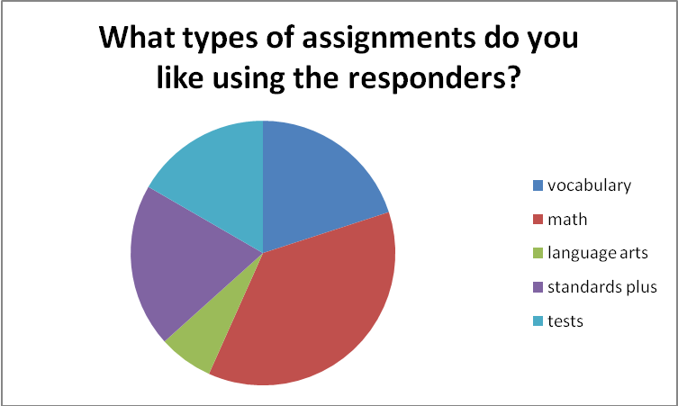

What about student engagement?
Some of the great features about using the technology from the teacher perspective are: students can see their results immediately, while the test is still in their minds, it excites them to do anything that breaks from the norm, students have to focus on the computer projected in the front of the room, they can’t be distracted by others, and the idea of using a tool like a cell phone or TV remote causes the student to think of the lesson as a fun activity. Mrs. Del Saz said that her students love the immediate feedback; “My students then want to know specifically which ones they missed so I give them the answers to correct their own work afterwards. Some of my students have become interested in the item analysis…it provided motivation to work harder on the needed skills” (L. Del Saz, personal communication, November 10, 2009). Mrs. Jonathan also commented that students like to see how they are doing compared to the other students without feeling uncomfortable (W. Jonathan, personal communication, November 9, 2009).
What do you like or dislike about the responders?
The students had lots of positive comments about their favorite part of the responders. Their answers ranged from simply pushing the buttons, to going back to check their answers, to seeing everyone’s answer. One student said, “It’s fun when we do 2Know thing where you get to see a graph after everyone answers” (5th grade student at Truman elementary, personal communication, November 16, 2009). The students enjoyed seeing their responses as a group, letting them know that they might not be the only person who chose a particular answer, even if it’s the wrong one. Kay and LeSage (2009) find that when using a student response system, students report being more interested in concepts presented. Another student commented, “We don’t have to wait to get our test graded,” (5th grade student at Kennedy elementary, personal communication, November 16, 2009) allowing the student and teacher the immediate feedback necessary for meaningful re-teaching of a concept.
Have you noticed an increased participation and comprehension in the students?
Teachers are also excited that when they use the responders, they get full classroom participation. According to Salend (2009), “An essential consideration is whether using technology will facilitate the teaching, learning, and assessment process without altering the classroom-based instruction” (p. 49). Mr. Armstrong commented that “With responders, they are communicating nonverbally, which is less threatening to some” (S. Armstrong, personal communication, November 9, 2009). Additionally, students who have the incorrect answer can see that there may be other students who missed the same question. The students are not alone in their misunderstanding and that provides a great feedback tool re-teaching guide for the teacher.
Gary Morrison from Qwizdom (a company who manufactures student response systems) says, “It can help teachers quickly identify knowledge gaps so that their teaching is more informed” (Frankel, 2007, p. 54). When questioned about student comprehension, Mr. Amparo said “I think students put more pressure on themselves to perform because they know that within a few minutes they will know how well they did…they know I will use the results immediately to guide instruction and they don’t want to get extra help for making a simple mistake” (A. Amparo, personal communication, November 10, 2009). 70% (7/10) of the teachers feel that their students will show improvement on the language arts benchmark exam, referencing increased achievement already in formative assessments. When these systems are used, teachers know immediately whether students understand concepts and the teacher can then in turn provide immediate feedback and review the topic, or save time and move on to the next subject (Kenwright, 2009).
What do you think the results will be on the benchmark exam?
When asked how they will perform on the language arts common benchmark assessment(DSAT) that is being given the week of November 16, 2009, 10% (30/300) actually thought they would score 100%, and 69% (207/300) felt that they would score a higher grade than in the past. Kenwright (2009) has shown that when engagement increases and student response systems are used for summative assessments, students’ grades averaged 8% higher than the previous year when these technologies were not available.
Benchmark Assessment Results
The English Language Arts (ELA) benchmark exam was taken over the period of 2 weeks, beginning Monday, November 16th, and finishing on Monday, November 30th. One school site, Washington Charter elementary has yet to complete the exams due to a modified curriculum schedule. The students were scored on 3 strands: Reading (ELA.5.R), Writing (ELA.5.W), and Conventions (ELA.5.C). Using an independent t test to compare scores for participating and non-participating students the results for strand ELA.5.R were:
Difference | Sample Mean | Std. Err. | DF | T-Stat | P-value
μ₁ - μ₂ | 0.007775 | 0.033137 | 41 | 0.23463 | 0.8157

Because the probability level (p-value) is greater than the alpha (α) level of 0.05, the difference is not statistically significant and therefore the use of the responders cannot be attributed to an increase in student scores.

In comparing strand ELA.5.W:
Difference | Sample Mean | Std. Err. | DF | T-Stat | P-value
μ₁ - μ₂ | 0.019867381 | 0.030098 | 41 | 0.66009 | 0.5129

The p-value is less than the previous strand, but still greater than the α level, and therefore the difference is not statistically significant. Results continued to improve in strand ELA.5.C, with similar results of the T test:
Difference | Sample Mean | Std. Err. | DF | T-Stat | P-value
μ₁ - μ₂ | 0.018938571 | 0.024069 | 41 | 0.78683 | 0.4359

In the final T test, comparing the overall results of the benchmark exam between the 2 student groups, the results were consistent.
Difference | Sample Mean | Std. Err. | DF | T-Stat | P-value
μ₁ - μ₂ | 0.015526984 | 0.027245 | 41 | 0.5699 | 0.5719

The p-value is greater than the alpha level (0.5719 > 0.05), so there is not a significant difference between the students’ scores in EETT participating and non-participating classrooms. Therefore, we fail reject the null hypothesis that there will be no difference between the 2 groups of students’ scores. The impact of the use of technology in preparing for and taking the benchmark exam, did not appear to have a positive statistical impact on the students’ scores (Mertler, 2009). However, the overall differences in scores can be represented in the following graph showing that, while it cannot mathematically be related to the use of technology, students in participating classrooms scored higher than those not in classrooms with the new technologies:
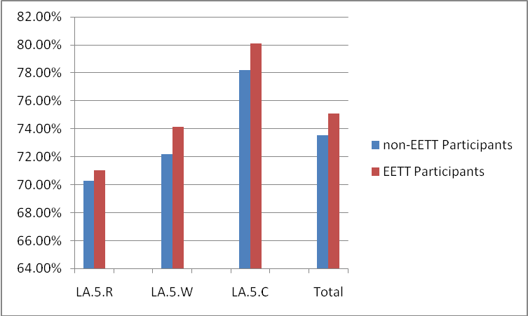
Scores from participating teachers’ were also compared longitudinally. The data was from different groups of students, but the same 5th grade teacher over the last 2 years. The purpose for comparing this data was to find if the addition of the technology would have an impact on the teacher and his or her delivery of the content. The data from the first benchmark exam from the 5th grade teachers last year (2008-09) showed that 43% (401/918) of the students scored proficient or advanced. The data from the first benchmark exam from the 2009-10 school year showed that the same teachers now had a student proficiency of 48% (431/893).
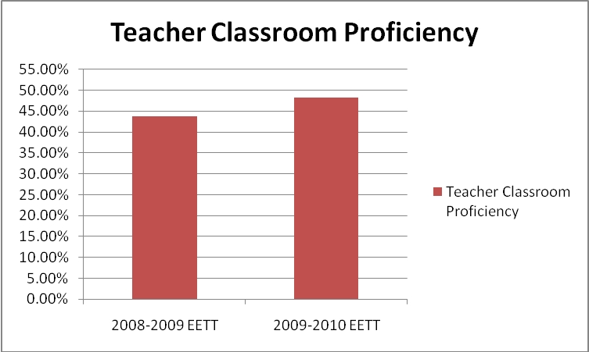
The current 5th grade students in Desert Sands USD had the opportunity to utilize new technologies if their corresponding teachers chose to participate in the EETT grant. The grant began in September of 2008, with the overall goal of improving academic achievement, particularly within the English Language Arts (ELA) content area. Their adopted text book remained the same; therefore the tools listed below were the only change in the ELA curriculum for the last two school years. Participating 4th grade teachers each received a set of Renaissance© responders, 4 thin-client laptop computers, 7 headsets for podcasting, 3 full days of training, and access to technology-rich lesson plans for each theme in their ELA textbook.
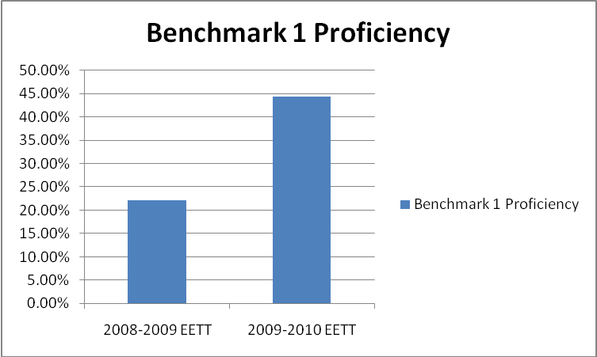
Students had only limited access to these resources from the start of the school year due to a time delay in the release of funds for the EETT grant state-wide. Nonetheless, teachers had full access to the lesson plans from the start of the year and the remainder trickled in with full access by January. In November of 2008, students took the first ELA benchmark exam with 22.14% (439 out of 1686) passing with a proficient score (75% and higher). Proficiency is determined by the minimum score a student must receive on the California Standardized Test, 350 out of 500, or 75%. At the start of the 2009-2010 school year, participating 5th grade teachers were given immediate access to the above resources. When students took the first benchmark exam of the new school year, the results showed that their proficiency had increased by more than 20% over the previous year. In fact, 44.31% (619 out of 1397) of students scored proficient on the ELA exam.

Action Plan and Reflection
From completing this study, I learned that while results may not be directly related to the increase in achievement, the excitement about learning can be. Students feel more involved in the learning process and actually believe taking tests can be fun. The amazing increase in proficiency over the last year is certainly worth noting. Beginning with less than a quarter of students district-wide displaying ELA proficiency last year, and beginning this year with nearly half of the students now proficient is incredible. Those responsible include: the 4th and 5th grade teachers, the technology teaches on assignment (T²OAs) who conducted the tech trainings, the current 5th grade students, and the state of California for providing grant funds to purchase the equipment. These current results have already been shared with the participating classrooms because as soon as they completed their tests with the responders, they were able to see their scores. They also were able to see how their scores compared with the rest of the district through the use of the Desert Sands Assessment Tool (DSAT).
The improvement in grade level proficiency and academic achievement will be shared at the next bi-monthly technology advisory committee meeting in December, comprised of student, parent, teacher, and classified representatives from across the district. These achievements will be shared with grant mentors at their next meeting in January, and with elementary school principals at their next meeting in January as well. This achievement will also be reported to the state in the EETT mid-year report in February, and final report in June. Future data will continue to be collected by the T²OAs as the remaining ELA benchmark exams are completed throughout the school year and reported to the state.
As I reflect on the process of this action research, I feel especially proud, because I played a role in helping students. While I may not have been the teacher in the classroom day after day, I was a part of the team that brought the technology to the schools. I assisted in training the teachers to use the equipment, and in how to analyze their scores for immediate feedback and re-teaching of their students. I thought it was helpful to include teacher and student perceptions of the technology into the overall results. While it is often only the final score that counts, understanding the process of getting there and the attitudes related to that process are important. This was also important for me to have my own piece of data creation because I did not have any part in the creation of the benchmark exam, that role is maintained by the Educations Services department of the school district. If I had to start over from the beginning I would have liked to include more district-wide quizzes from DSAT throughout the past few months, to further analyze improvement throughout the trimester. It would also have been interesting to see how students might have scored on a pre-test or a first version of the benchmark given at the start of the school year.
While the data showed that there was a slight difference in scores between participating and non-participating classrooms, there are still too many variables to conclude that the technology played a role in the increased achievement. The only way that I can think of more accurately measuring technology’s effect would be to have a control group of students complete 4th grade standards without technology the first time, and then complete 4th grade again using technology the second time. Then the students, standards, and measurement tools would all be the same. However, since that is impossible, future research may include observing students from one school site and having two teachers (one participating and one not participating) co-teach both sets of students during the following trimester. This would allow students to be exposed to delivery of content from both teachers, but one group would have technology and the other would not. I will continue to look for further ways to validate the use of technology in increase student proficiency; perhaps the California Standardized Test in the spring will further aid this process.

References
California Department of Education. (2009, June 08). EETT Competitive: Round 7 Forms. Retrieved October 20, 2009, from California Department of Education: http://www.cde.ca.gov/ls/et/ft/eettc08r7forms.asp
Frankel, H. (2007). Honesty hotline. Times Educational Supplement, (4728), 54-55. http://search.ebscohost.com.libproxy.lib.csusb.edu
Guhlin, M. (1997). Integrating technology from the classroom up. Technology Connection, 3(9), 25. http://search.ebscohost.com.libproxy.lib.csusb.edu
Kay, R., & LeSage, A. (2009). Examining the benefits and challenges of using audience response systems: A review of the literature. Computers & Education, 53(3), 819-827. doi:10.1016/j.compedu.2009.05.001
Kenwrigth, K. (2009). Clickers in the classroom. TechTrends: Linking Research & Practice to Improve Learning, 53(1), 74-77. doi:10.1007/s11528-009-0240-7
Mertler, C. A. (2009). Action research. Thousand Oaks: SAGE Publications.
Rigeman, S., & McIntire, N. (2005). Enhancing Curriculum and Instruction Through Technology. T H E Journal, 32(12), 31-34. http://search.ebscohost.com.libproxy.lib.csusb.edu
Salend, S. (2009). Technology-based classroom assessments. Teaching Exceptional Children, 41(6), 48-58. http://search.ebscohost.com.libproxy.lib.csusb.edu
Swain, C., & Pearson, T. (2002). Educators and Technology Standards: Influencing the Digital Divide. Journal of Research on Technology in Education, 34(3), 326. http://search.ebscohost.com.libproxy.lib.csusb.edu
Williams, L., Atkinson, L., Cate, J., & O'Hair, M. (2008). Mutual Support Between Learning Community Development and Technology Integration: Impact on School Practices and Student Achievement. Theory Into Practice, 47(4), 294-302. doi:10.1080/00405840802329219

Appendix A
Semi-Structured Interview Questions (teachers):

- How often does your class use responders?
- What types of situations are you using the responders?
- What is your perception of the student use of responders?
- Why do you believe students are more engaged when using the technology?
- What type of change have you noticed in your students when they use responders to answer rather than class discussions?
- Have you noticed an improvement in student comprehension?
- What items are you using as measurement for increased comprehension?
- What do you think the benchmark exam results will be for your students?
Semi-Structured Interview Questions (students):

- How often do you use responders?
- When (what situations) does your teacher use responders?
- For what types of assignments or lessons do you like using the responders?
- For what types of assignments or lessons do you not like using the responders?
- What is your favorite part about using responders?
- How do you think you will score on the language arts benchmark (DSAT) assessment?
Benchmark Exam – Attached in PDF format

- Reading Comprehension Common Assessment
- Writing Strategies Common Assessment

